Reshaping Languages in Higher Education Conference 2014

ABSTRACTS

9th-10th July 2014

#LLASconf2014

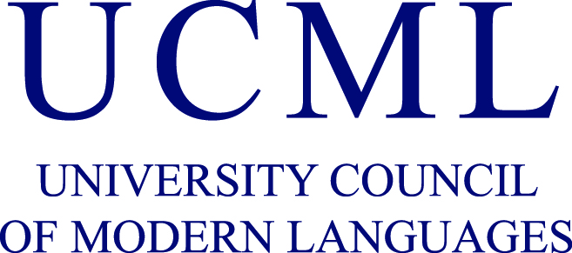
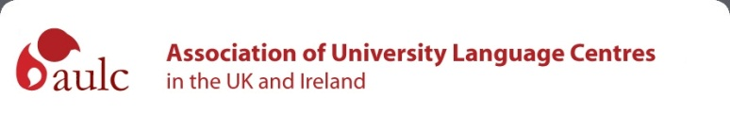

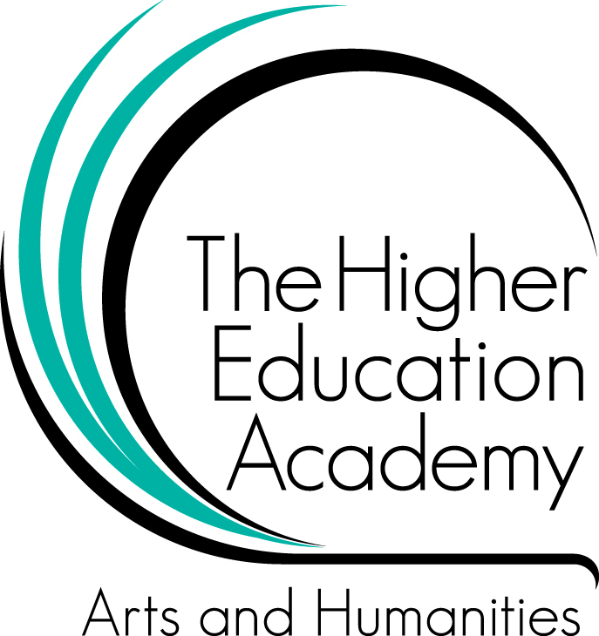

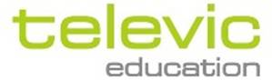
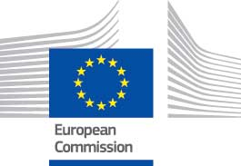

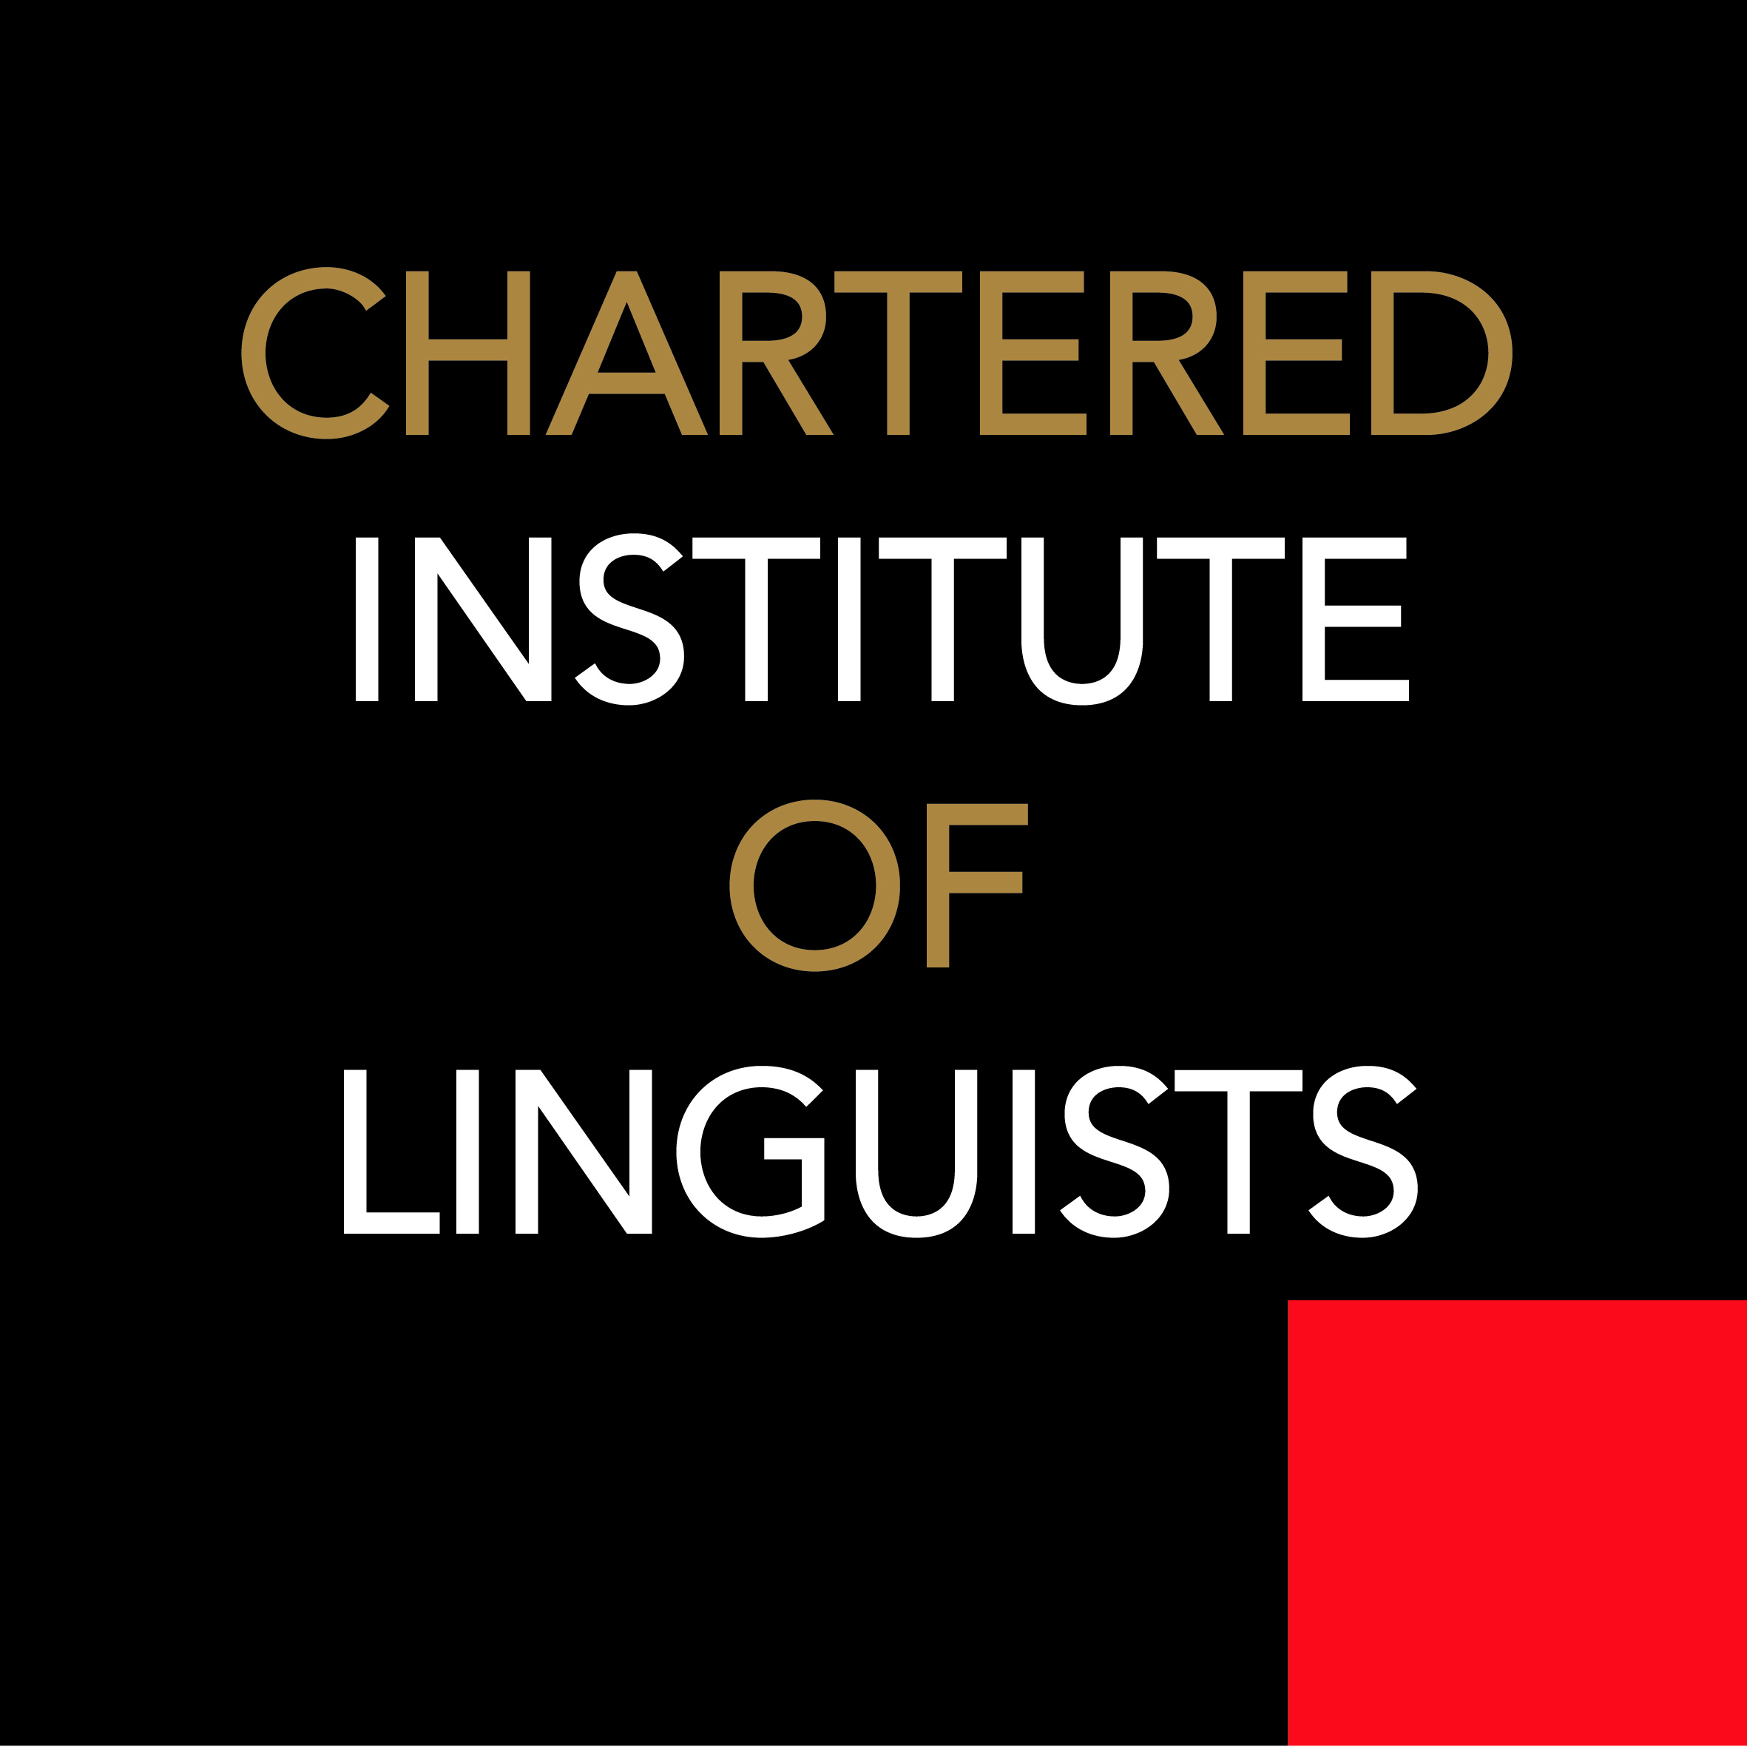
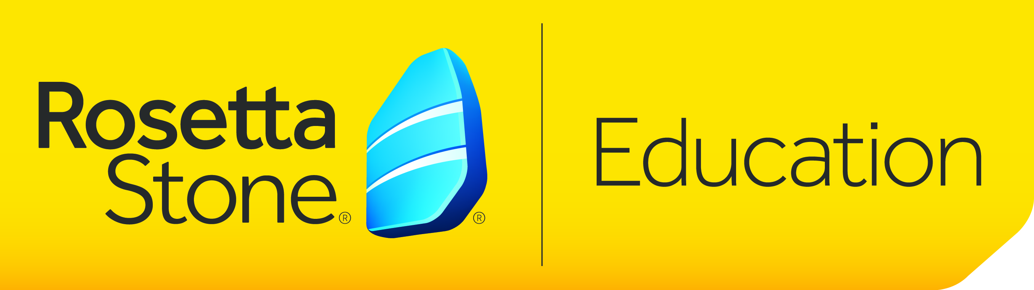

ABSTRACTS

WEDNESDAY 9th JULY 2014
Jocelyn Wyburd - University Council of Modern Languages (UCML)
How fertile is the ground for us to reshape languages in UK Higher Education?

The HE languages community in the UK has been 'mapping new landscapes' or seeking to 'navigate' them for many years, conscious of the many challenges that face us. We have not stood still. We have engaged both separately and collaboratively in re-shaping curricula and programmes and raising the profile of our disciplines, with some considerable success, including through wider public engagement. There are, however, undoubtedly still many challenges to face too, and they are not unique to the UK. The talk will chart the current landscape, noting the opportunities now available to us to reshape the future of languages in UK Higher Education.

Biography
Jocelyn Wyburd is currently Director of the Language Centre at the University of Cambridge and has been Chair of UCML since January 2014. UCML is the overarching representative body for languages in Higher Education in the UK, whose members include both Universities and subject associations. Jocelyn also Chairs the Routes into Languages national Advisory Board. She was previously Director of the University of Manchester Language Centre for 12 years, until 2011, has been active in Routes into Languages consortia in both the North West and now the East of England. She was also Director of the North West Centre for Links into Languages 2009-11.
Mark Hopkins, Hong Kong University of Science and Technology
Through a glass, darkly : processes and effects of teaching L3 and L2

This presentation will explore the mechanisms of teaching and learning a 3rd language (French, Mandarin Chinese) through the medium of a 2nd (English) by two instructors at the Hong Kong University of Science and Technology, and attempt to assess to what extent they are accepted by their learners. Preconceptions of teaching methodologies and representations of the status of both mother tongue and target language and their respective native speakers will be analyzed and compared for both groups, and implications drawn for the mediation of direct communication between French- and Chinese-speaking learners. Special attention will be paid to evidence of change in attitudes and approaches by learners and instructors during the course of the 2-3 month language programmes. Finally, the extent to which any language can be value-free in terms of its pedagogy will be considered in relation to the two possible future world languages, Chinese and French, in contrast to the mediating established world language English.
Joanne Hooker & John Holder, Southampton Solent University
Dealing with Diversity : Rethinking the Lecture – Seminar Format in language and Content Provision

Students were canvassed through face to face sessions in class as well as through 2 online surveys. The first was the generic Southampton Solent University unit feedback and the second was a tailor made survey for this unit designed using Survey Monkey. All three methods overwhelmingly showed that students preferred the flexibility of the workshops and highlighted the fact that they acknowledged they were improving certain skills such as: researching, expressing their own ideas, interacting with classmates and it is preparing them for their final year.
In addition, they specifically identified understanding of global issues, improvement of language skills, greater appreciation of classmates and their culture and their ability to continue despite making mistakes. Some of the comments are given below:
"I have really enjoyed the lectures, especially when we discuss each topic in class and share ideas. The tutors have been great, I feel they have much knowledge about the topics and have been very helpful with our assignments when it comes to feedback and advice. The mini-presentations have made me more confident when speaking in front of the class, although I sometimes would prefer we could just discuss the topic instead of presenting it. I enjoyed the portfolio and the way it was divided into three parts. In this way you could work through each part at a time, which made me less stressed. All in all, I am happy with this unit and feel I have achieved better skills in presentations and writings. One thing I also enjoyed was when Bob thought us new words. For me as an international students, there are many words I do not know about, and my vocabulary is something I need to work on further. Thank you. "
"+ involvement of the teachers + organized classes + language support + improve research abilities + nice atmosphere + mini-presentations helped to speak in front of people , gain more confidence - not enough time for each topic - topics were treaten a little too superficial advise: less topics and more information to each one. All in all: teachers showed a lot of effort which was positive, nice class atmosphere and i improved my interpersonal skills in english which i really appreciate. "
"a good way to go through a topic better than a simple seminar and lesson "
Despite the overall positive comments, and feedback on the unit in general, only a few students thought the unit would help them prepare for work and get a job. There were also comments about the amount of topics and time available to cover relevant materials. In conclusion, it seems that although the students acknowledge they are developing transferable skills they are not making that connection with employability. For the next delivery we shall look at identifying how skills and awareness of those skills will make them more employable- this can be done through review of the CBI 7 core skills and using the Solent Employability Compass
Elia Lorena Lopez, University of York
Reflection as a key learning tool in ab initio language delivery

This paper intends to highlight the great benefits of introducing weekly reflection as a key component in the delivery of Ab initio Spanish language.

During a two-term trial period, students were encouraged to input a 200-word weekly reflection on their learning on a VLE Journal by considering a) the aspects they found easy and challenging to deal with (and why) and b) the action points for improvement.

This weekly input provided me with important and often unexpected information that helped me to reassess my approach to teaching specific areas, for instance, more complex verb tenses, according to the group’s needs.

The paper will focus on presenting the following evidence:
- The procedure followed
- The grammatical areas in which the weekly reflection helped to improve the teaching and learning process
- How this reflection was beneficial for students (from the reflective exercise and from what was collected from a questionnaire given to students at the end of the trial period)
- Advantages (both for students and for instructor)
- The challenges of this teaching method and the way forward (to implementation in the Ab initio curriculum?)

It is intended that the specific methodology together with the detailed outcomes provoke discussion and analysis of this method with other (Ab initio) language instructors.
Kate Borthwick & Irina Nelson, University of Southampton
The XML project : digital literacy and curriculum innovation in ab initio Spanish

This presentation will outline the findings of a small-scale project which sought to enhance and explore aspects of digital literacy amongst a group of Spanish language students at a UK university. The Higher Education Academy-funded ‘XML project’ ran in semester 2 of the 2013-14 academic year and it piloted a model for the student production of e-learning resources as part of a languages curriculum.

The primary aim of the project was to engage language students in the creation of online educational resources supporting the learning of Spanish language and content, as an assessed part of their studies. Students were trained in the use of a free online authoring tool, called Xerte, and used it to work on the creation of interactive digital learning objects fusing knowledge and practice in language and culture. The rationale for project work is to enhance student digital literacy and digital skills, encourage reflection on the students’ own learning process through creating learning activities for others, and offer a more innovative, interesting and collaborative approach to language teaching and learning.

This presentation will outline the project’s aims and approach, and report on findings including the attitudes and experiences of the students involved, and the perceived impact on learning.
Uwe Baumann & Elodie Vialleton, The Open University
From modules to qualifications – reshaping the languages curriculum at the Open University

The Open University (OU) has recently had to undergo fundamental and wide-ranging change in order to operate successfully in the new UK Higher Education environment. Amongst others, this has repercussions on curriculum design: since its founding, the Open University (and within the institution, the Department of Languages) has operated an entirely modular curriculum to which named degrees were introduced in the early 2000s. To respond to external constraints, the OU has set out to move its entire curriculum from modular study (or M-world) to qualification based study (Q-world). The presentation sets out how the OU Department of Languages responded to the institutional changes and moved from module- to qualification- based curriculum design, across all languages and all levels. It will describe the complexity of the process, discuss challenges such as the need to develop linguistic proficiency, intercultural communication skills and other subject-specialist content from beginners’ to bachelor’s level progressively and coherently, and opportunities such as the inclusion of new dimensions to the curriculum, addressing the need to integrate systematically other transferable skills that define graduateness for students from the Open University. It will also present the main outcomes of the process and show how it will be implemented.

Elinor Parks, University of Hull
Investigating the effects of a dualistic degree structure in Modern Languages – Implications for Criticality and Intercultural Competence

The paper describes the concerning status of Modern Languages as a discipline with emphasis on the division between ‘language’ and ‘content’ in Higher Education.
Implications of such division for the development of intercultural competence and criticality are discussed and an argument is made for new directions in Modern Languages as specialist study.

As Byram (2008) notes, ‘if language learning is to be part of a policy of internationalisation, it has to be more than the acquisition of linguistic competence.’ Intercultural competence, he argues, offers ‘the opportunity for ‘tertiary socialisation’ […] in which learning a foreign language can take learners beyond a focus on their own society, into experience of otherness.’ (p.29). The Southampton Project similarly highlights disparity between the two areas and, in reference to language, notes that ‘the focus on criticality development itself is less central than in other areas of the ML curriculum, especially the ‘content’ courses.’ (Brumfit et al., 2005:159)

The characteristic of a ‘dualistic’ structure present in Modern Languages is not solely applicable to a U.K. context. The American MLA Report (2007), as well as reports issued in the UK such as the Worton Report (2009), equally refer to a division in the content and language elements of the degree and advocate for a curricular reform in which a more integrative approach is adopted for languages in Higher Education.
Ian Lyne & Adam Walker, Arts and Humanities Research Council (AHRC)
The Open World Research Initiative

Poster exhibition

Presenter: eLanguages, Modern Languages, University of Southampton
Vanishing boundaries: connecting virtually with students to deliver educational programmes
Education is changing to meet the needs of a changing world. Institutions are delivering an increasing number of their educational programmes in the form of online distance learning programmes. Online tutors, self-paced independent learning resources, social networking tools and rich audio-visual content are the components of online course design in the twenty-first century, and the emergence of an increasingly open online culture means that institutions are seeing the benefits of making courses and educational resources freely available. This poster will explore the student response to four such offerings for international students delivered online from the UK.

Presenter: eLanguages, Modern Languages, University of Southampton
An evaluation of student and teacher use of online resources in EAP on a university pre-sessional course

Online language learning resources now have a role in many English language programmes at university level, including Pre-sessional Courses in English for Academic Purposes (EAP) and Study Skills. At the University of Southampton, an online toolkit of interactive learning resources in EAP and study skills, produced in-house, has been closely integrated each summer with pre-sessional course teaching over a number of years. The EAP Toolkit provides scope for blending with taught courses, by supporting and consolidating classroom learning and through teacher use in the classroom, as well as being a rich resource for students’ independent study. Over 100 online learning activities provide academic skill development in key skill areas such as academic writing skills; reading and critical thinking; and academic speaking, listening and note-taking, as well as grammar and vocabulary. This poster will introduce the EAP toolkit and its design, and present findings from a survey into pre-sessional teacher and student use of this resource, and their attitudes towards the blending of online resources in face-to-face taught courses, in general. This research shows the range of ways in which the resource can be embedded in a taught EAP course and highlights changing teacher and student attitudes towards the roles of the traditional textbook and online learning resources on such courses.

Please note : there are more posters available to view at the conference
Catherine Chabert, Cardiff University
Reshaping Modern Languages at Cardiff University – a case study

Based on the major developments in Modern Languages which have recently taken place in a Russell Group university, the paper explores the different stages and elements which have formed the planning and implementation of a new Modern Languages strategy.

To do so, the model of the policy network will be explored to assess the extent to which it has shaped the major phases of these developments. At a time when there is a growing awareness on the need to re-think the ways in which languages are offered in higher education, the intention is to use this theoretical framework to identify what are or what should be the elements of a successful implementation of a language strategy
John Morley, University of Manchester
The Growth of the IWLP – how institution wide language programmes can change the landscape of languages

At least 54,000 students in UK universities study languages in a non-specialist capacity, often as an elective component of their degree, sometimes as an adjunct to their academic studies. This important area of activity in higher education, commonly referred to as Institution Wide Language Provision or IWLP, has grown rapidly in recent years whilst it seems that numbers enrolling on specialist language degrees has declined. As IWLP has grown and evolved organically in response to student demand, the actual arrangements and management structures for delivering this provision vary considerably across the sector. Depending on the institution, IWLP may only include credit-bearing provision to non-specialist language learners; in other cases, it may only encompass non-credit language courses to students. Activity may be managed from within a university language centre or it might be offered alongside specialist degree programmes and managed from within a language department. The sector is also diverse in terms of the ranges of languages offered, with some institutions offering only three or four languages and others offering up to twenty. The British Academy as part of its Born Global project is also interested at mapping how the growth of this provision could redefine both the delivery and and role of languages in the 21C curriculum. This paper will present the results of a recent UK-wide survey on IWLP activity which sought to find out more about: the availability and demand for different IWLP languages and note changing trends, the arrangements universities have for delivering these courses and the degree of institutional support, and the profile and motivations of the students who choose to study IWLP languages.

Enza Sicilliano Verruccio & Pilar Gray-Carlos, University of Reading
Learning to learn languages : the OpAL project

Open Access to Languages (OpAL) is a project based at the University of Reading aiming to produce freely accessible interactive support material for students who wish to embark on the study languages both at degree level and within the IWLP, but who may have never studied languages before or who have weak basic competences and strategies in language learning.

The project, funded by the University of Reading and Routes into Languages, is conceived as a ‘bridge’ to support the university language learner in the transition from school, by addressing in particular those areas where weaknesses due to lack of previous exposure to language learning, as well as to limited or inadequate language learning skills and metalinguistic competence (= grammar!), are likely to hinder progress in a more or less intensive undergraduate language curriculum.

Whilst tracing and evaluating the evolution and progression of this course into an open educational resource (OER), the paper will focus on the highly collaborative nature of the project, which as well as being the result of the contribution of specialists from separate language provision centres within the same institution, is also a successful model in ‘learning by teaching,’ whereby students’ actively collaborate in the design and delivery of the project’s learning material.
Olga Gomez-Cash, University of Lancaster
Effective transition in language learning – secondary to HE

There is an increasing scholarly and institutional interest in transition to HE and the importance of the first year of university experience, although very little of it is as yet subject specific. In the light of GCSE and A level reform generally and the issues facing the study of languages in the UK, to investigate the transition in language learning from secondary and/or A level to HE seems timely. To do this, I combine research into transition scholarly literature, evidence gathered from the experiences of language undergraduates and secondary teachers, and a close look at the context in which we teach languages today both at secondary and HE and some of the effects of this changing context. My paper explores:
a) the ways in which transition research highlights issues for language learning
b) the specific issues that language learners face in the mismatch between sixth form and HE and
c) ways in which universities and schools/sixth form colleges can productively work with this 'culture shock', in order to engage in a discussion about fostering language learning generally, and specifically an effective transition between secondary and tertiary language learning.
Ruth Hatcher, Laurence Millard & David Tual, University of Cambridge
Looking back to take things forward : reflection on a language portfolio

This paper will report on the recent introduction of a reflective portfolio as a summative
element of the Language Programme for Engineers within the Engineering Department at the University of Cambridge. This initiative included the optional use of Google Drive as a repository for students' work and as a tool for the teachers to provide feedback and guidance.

After outlining the institutional context in which this pilot project was carried out, we will briefly present the content and objectives of the portfolio, as well as the possibilities offered by Google Drive in terms of monitoring and feed-backing on students' work and progress.

As opting in or out of the online dimension of the portfolio was left to the teachers'
individual decision, the motivations behind this initial choice will be explored before sharing the feedback on experience from the teachers' and the students' points of view.

Some concluding remarks, including the challenges and limitations attached to it, will lead us to consider future perspectives for such practice. We hope this return on experience will benefit colleagues who might be considering the introduction of a similar component in their language assessment.
Charles Burdett, University of Bristol & Naomi Wells, University of Warwick
Transnationalizing modern languages : Mobility, translation and reframing the discipline

Translation, especially when studied in connection with forms of mobility such as migration, provides a key entry point for a rethinking of Modern Languages on a transnational basis. World-leading research on practices of linguistic and cultural translation is carried out across Modern Languages, but has yet to exert its full impact on how the discipline articulates its identity both within the academy and without.

The AHRC-funded ‘Transnationalizing Modern Languages’ project will use the close study of modes of linguistic and cultural translation within the framework of Italy’s complex history of migrations as an opportunity to develop a transformative paradigm for Modern Language studies in the twenty-first century. Using the knowledge and the methodologies of which the discipline can claim ownership, in relation to language exchange and cultural interchange, will demonstrate the practical currency of Modern Languages research. Working closely with subject associations and fostering public debate between specialists and policy makers will also enhance public understanding of the discipline.

This paper will address how the project intends to advance the methodological core of the discipline in order to stimulate new approaches to the teaching of Modern Languages and allow the discipline to reframe an important part of its identity.
Helene Pulker, Bill Alder, Elodie Vialleton & Tita Beaven, The Open University
Lessons learnt from online synchronous teaching in a language MOOC

One of the major factors currently contributing to the reshaping of education around the world is the rise of MOOCs or Massive Open Online Courses. The UK Higher Education Languages landscape will inevitably be affected.

Typically, a MOOC is an event around which people who are interested in the same topic get together and work in a structured way. Learners engage with online content provided by facilitators and make connections with peers through social networking tools. Opportunities for synchronous contact with subject experts are generally limited in MOOCs.

By contrast, one of the key features of ‘Travailler en français’, the first MOOC dedicated to French language teaching jointly designed and delivered by the Department of Languages at the Open University and colleagues from the Institut Français, offered ten synchronous sessions, five focussing on content, and five on language.

Based on the analysis of the recordings of the five language sessions, and on the reflections of two of the facilitators, this presentation considers whether the pedagogical principles drawn from their expertise of online French teaching applied to the context of a MOOC and whether the facilitators’ beliefs and assumptions were readjusted as a result.

Julie Watson, University of Southampton
Exploring international student satisfaction with online courses in acculturation and English language development

The transferral of taught courses to an online environment and the development of new online courses to reach a distant student audience is gathering pace as MOOCs provide the training ground for many of those involved in their conversion or creation. A question that will need to be asked is what the student reaction is to types of online course. In Modern Languages at the University of Southampton, we have been delivering online courses to international students for some time and have gathered feedback about their satisfaction levels with this mode of teaching and learning. This presentation will evaluate international students’ satisfaction levels with three types of online course delivered in a higher education context. The courses focus on developing students’ English for Academic Purposes (EAP) and/or supporting their transition to UK academic culture. Each course is characterised differently in terms of whether it is tutored or untutored; assessed or not assessed; involves peer contact or not and is delivered over a fixed or flexible time period. The impact of these factors on student satisfaction will also be taken into account. The presentation will showcase three online courses and compare the student reaction to each of them.
Professor Jenny Jenkins, University of Southampton
The paradox(es) of English in Higher Education

Universities in many parts of the world, not least in Anglophone countries, proclaim themselves as ‘international’. This tends to mean primarily that they recruit high fee paying (‘international’) students from other countries and teach them in English medium. Although there has recently been some discussion (if little change as a result) of global citizenship, cultural issues, and the like, the implications of English as HE’s lingua franca have so far been ignored. And so, despite numerous research-based publications on English as a Lingua Franca in HE settings, English is still seen as a peripheral matter, merely the subject of English language entry tests and remedial teaching in universities’ English language centres for students whose English differs from that of native users. Paradoxically, then, ‘international’ universities regard national English (typically British or North American) as a given, and do not consider the possibility that it is inappropriate in international academic settings, let alone that ‘international’ could logically be taken to imply a multilingual language policy rather than ‘English only’. In my talk I will discuss the findings of my recent empirical research (Jenkins 2014), demonstrate how the persistence of an out-dated approach to university English disadvantages both non-native and native English speaking students and staff, and explore what actions could be taken to internationalize universities in this respect.

Biography
Jennifer Jenkins is Professor of Global Englishes at the University of Southampton and founding director of its Centre for Global Englishes. She has been researching English as a lingua franca since the 1980s, and has published numerous articles and chapters on the subject, as well as three monographs: The Phonology of English as an International Language (OUP 2000), English as a Lingua Franca: Attitude and Identity (OUP 2007), and English as a Lingua Franca in the International University. The politics of academic English language policy (Routledge 2014). She has also published a university course book, World Englishes, whose third edition is currently in press as Global Englishes (Routledge).

THURSDAY 10th JULY 2014
Giuliana Pieri, Royal Holloway, University of London
Languages and Disciplines in the 21st Century : Interdisciplinarity and Italian Studies
Both funding bodies and academic institutions over the past few years have begun to use more consistently an old/new buzzword: interdisciplinarity. This often ill-defined concept is used to inject new energy to the way both research and teaching are presented in many institutions. Yet, research and teaching in universities still remain fundamentally well-within existing disciplinary boundaries. Even the relatively more straightforward interartistic links are viewed in many quarters as challenging at best. What is the place of Italian (and languages at large) in all this? Do languages by definition challenge existing disciplinary boundaries? Has the curriculum in Italian Studies changed since the discipline first became part of UK academia? Have new partnerships with other disciplines been fostered, and if so, which disciplines are working more productively with Italian?
This paper builds on two interrelated projects: the HEA funded Teaching Italian Studies in the 21st century: Trends and Challenges, and the AHRC funded Research Networking grant, Interdisciplinary Italy 1900-2015: Art, Music, Text (http://interdisciplinaryitaly.com/). Both projects focused on Italian Studies as a means to engage with broader issues of curriculum design in languages and the forces that shape it, as well as the potential and pitfalls of interdisciplinarity in teaching and research.
Cinzia Bacillieri, University of York
Reshaping language teaching in higher education : delivering an interdisciplinary specialist language module to History of Art students

This presentation will describe the challenges of creating and delivering Italian Reading Skills for Art Historians, a content-integrated language course created for ab-initio Italian language students (the majority of which first-time language learners), as part of the degree in History of Art at the University of York.

The talk will present experimental initiatives aimed to facilitate the acquisition of specialist language skills essential to the History of Art discipline and how the effects of these had a significant impact on the applied language teaching methods. Furthermore it will illustrate the challenges faced by the language teacher when planning and delivering a specialist language module that has to be fully integrated into a History of Art undergraduate degree programme (the aim of the specialist language course Italian Reading Skills for Art Historians offered in York is that to enable History of Art students to carry out researches in Italian as well as to maximize the benefits of students’ trips to Italy). A number of case-studies will illustrate the impact that the interdisciplinary nature of this course had in the applied teaching practice, students’ engagement and classroom activities: in particular how the integration between the language module syllabus and other components of the History of Art degree programme has lead students to experience a much deeper engagement in both disciplines. Particular focus will be given to the results of the collaboration between art historian and language teacher and its vital role in the creation of bespoke Art-related language teaching material.

Examples of technology-enhanced teaching (e.g. online personal portfolios, audio and video material) and how these were deployed to enhance the quality of the student engagement with pertinent art-related assessment activities, student-teacher interaction and monitoring of student progress will also be presented.

Ruth Whittle, Elisenda Marcer & Dorothee Sachse, University of Birmingham
Promoting graduate skills in ML students

It has become common place for universities to promise their undergraduates that they will give them graduate skills. Equally, we know that putting on employability events and sending students abroad cannot be the only means of fulfilling this promise. Additionally, a potential employer may not even be looking for their applicants’ languages as a hard skill. Soft skills, however, have become increasingly important (Goleman 2004) and this is an area where ML departments can and need to work more effectively.

In our current research project, Promoting the Reflective Learner through Blogging and Learner Diaries we explore the pedagogies that can engage students in reflecting on their learning not just as incremental acquisition of knowledge but in terms of looking for opportunities to develop professional attitudes. According to a recent study, students need to become able to evaluate their learning, find out that there are other perspectives than their own, and reflect on their choices (cf. Wilson et al. 2013). We will present how ML students think about their first year experience, and about their studies retrospectively, in order to then discuss suitable approaches for coaching students in graduate skills by engaging them through task-based blogging and learner diaries during their 4 years of study.
Alessia Plutino, University of Southampton
Bridging the gap : a self-discovering path into intercultural perception of self and the other

This paper will provide an overview of a Telecollaborative exchange project currently undergoing between the University of Southampton, United Kingdom and the University of Salento, Italy.
The project, called “Bridging the gap: a self-discovering path into intercultural perception of self and the other” investigates language and intercultural learning outcomes of a telecollaborative exchange and in particular the notion of ‘interculturality’.
Starting from the criticisms that Risager (2006) and others have expressed towards the tendency to locate culture with the ‘nation’ and uncritically identify static differences between national communities, the project also draws from the outcomes of Zu Hua’s work (2013) with Chinese and English communities, aiming to find out what people really do in intercultural encounters, how they construct and de-construct the notion of ‘culture’ and ‘identity’ and how these emerge in specific contexts of interaction and are made relevant and negotiated by the intercultural participants.
After briefly outlining the background at the basis of the project, as well as data collections and main objectives, the presentation will move into discussing the methodology used and how the telecollaborative exchange is conducted using CMC, highlighting pros and cons encountered so far.
A description of the pedagogical approach then follows, describing how materials provided by tutors on specific controversial issues affecting both countries, work as starting point and background for the CMC discussion. The aim of these discussions is to answer specific cultural questions as well as making students aware of their own positioning in respect to the topic discussed.
A series of activities is then demonstrated to provide examples of actual tasks carried out by students and their involvement in terms of independent learning and language acquisition.
The presentation will conclude by introducing the final assessment task that student will complete at the end of the exchange, focusing in particular on how this is designed to be a self-reflective process on students’ own language acquisition and intercultural understanding and how this can be shared with others for a more in depth self-analysis.

References
Risager, K. 2006. Global Flows and Local Complexities. Clevedon: Multilingual Matters.
Zu Hua (2013) Exploring Intercultural Communication: Language in action. London: Routledge
Lamy, M-N and Goodfellow, R. 2010. Telecollaboration and Learning 2.0. In Guth, S. and Helm, F. (eds) Telecollaboration 2.0. Berne: Peter Lang. 107-138.
Lamy, M-N. and Hampel, R. 2007. Online Communication for language learning and teaching. Basingstoke: Palgrave Macmillan.
O’Dowd, R. 2007. Online Intercultural Exchange: An Introduction for Foreign Language Teachers. Clevedon: Multilingual Matters.
Alison Fenner, University of Reading
Language Learning Advisor Scheme : Enabling students to take charge

Language study in HE is increasingly seen as a partnership in which the institution increases student engagement by equipping students with the skills necessary to direct their own learning. The Language Leaning Advisor scheme at the University of Reading trains undergraduate languages specialists to advise their peers in Modern Languages and the Institution Wide Language Programme, enabling them to develop autonomous learning strategies and promoting self-awareness, self-analysis and the ability to develop a successful learning path. The Advisors gain a deeper understanding of learning techniques which benefits their own linguistic performance as well as transferable coaching skills which improve their future employability. International mobility is encouraged since effective linguistic strategies play a key role in increasing self-confidence in communication.

The paper will examine the training, implementation and concrete outcomes of the scheme and its role in maximising student potential in HE and beyond. Its comparability with buddying schemes will be explored, and its future role in increasingly popular teaching methods such as flipped learning, which require students to accept more autonomy and responsibility for their own progress. The scheme’s popularity, adaptability and potential for further expansion will also be considered.
Sonia Cunico & Juan Manuel Garcia-Precedo, University of Exeter
Learning together – learning from and with each other : Towards a community of L2 users through a Peer Assisted Learning Scheme at Exeter
Peer Assisted Learning schemes and initiatives have been used in UK HE contexts since the early 1990s (Wallace, 1992; Rust & Wallace, 1994) but Modern Languages has been relatively slow in grasping the full potential of PAL schemes in foreign language learning and, more crucially perhaps, the wider implications that such schemes have in fostering and promoting students’ autonomy, engagement, employability skills, and a stronger sense of students’ identities in the imagined community of successful L2 users.

This paper will present how Modern Languages at Exeter has designed and implemented a scheme which encourages students to support each other’s learning, to work collaboratively across different years, and to benefit from each other’s competences. In particular, the scheme aims to develop more agency and self-regulation, as well as much needed employability skills by increasing students’ confidence in the value and quality of their expertise. Furthermore, the scheme encourages a more social view of language learning, less dependent on formal teaching, and more embracing of the richness of students’ experiences as expert language learners. It also encourages students’ self-reflection on their own learning goals and their language learning experience, and the value of sharing it with their peers in a collaborative and supportive learning environment. Finally, the scheme fosters the transition of the students’ identity from learner to expert user and ‘to full members of the community of practices to which they belong or to which they aspire’ (Lantolf and Pavlenko, 2001: 155).
Translating and Interpreting Panel
Helen Campbell, Director of National Network for Interpreting
Christina Schaeffner, from the National Network for Translation
Angeliki Petrits from European Commission Representation UK
Cathy Hampton, University of Warwick
Out of the frying pan and into the classroom : student producers transform their year abroad encounters into learning objects for schools

This paper will review the initial outcomes of a French department project currently running at Warwick University entitled ‘Finding a French education programme fit for 21st century British school children.’ Fifteen Year Abroad students on placements in France and Canada are engaged in a student-led project to source contemporary learning objects for years 9 and 12 pupils and to devise learning activities related to these. Last summer the students spent a day in local secondary schools reviewing current resources and talking to teachers. They have now gathered hard copy and online resources (children’s books and magazines, cartoons, school canteen menus, food packets, receipts, maps, video interviews with the classes they teach on key curriculum topics…) and are currently planning the creation of school packs and online resources aligned with the ML school curriculum. These learning objects will be trialled in a number of schools from September. A key project aim is to bring the live intercultural encounters offered by the Year Abroad experience to schools pupils, presented from the perspective of students close to them in age. This will offer schools and the university, each seeking to widen MFL participation, the chance to make a new voice for languages heard.
Sarah Schechter, Anglia Ruskin University
Collaboration – more than the sum of its parts...?
Ann Carlisle, Chartered Institute of Linguistics
Routes to Languages Qualification – combining the academic with the professional

This presentation will take a look at work currently underway at the Institute in respect of language qualification development to meet the needs of specialist and non-specialist linguists. It will consider the ‘pathways to language qualification’ which underpins the current IoL Educational Trust portfolio of examinations and frames the development of its language qualifications for the future.

In the context of decreasing numbers of specialist language learners in contrast to increasing numbers of non-specialists taking up a language alongside study in a different discipline, demand for language qualifications is changing. In response, the IoL Educational Trust is reviewing its range and levels of qualifications in the area of professional (translating and interpreting) as well as vocational (general and business) qualifications. The notion is to provide ‘pathways’ for development and progression at all levels, linking wherever possible with schools, universities and businesses to provide coherent routes through academic and professional qualifications to provide learners with recognition for their language skills and to equip them with the competencies they need to operate and communicate effectively in international and multilingual workplaces.
Billy Brick & Tiziana Cervi-Wilson, Coventry University
Add+vantage Coventry University : Delivering Institution wide languages provision with an employability framework

This paper will report on Coventry University’s unique Add+Vantage Scheme which is committed to encouraging students to enhance their employability competencies. The University implemented the scheme in 2006 to provide structured opportunities for students to develop reflect and become more able to articulate these employability competencies to potential employers. Most full-time undergraduates take part in mandatory employability related modules in each year of their degree. The scheme helps students to develop employability skills and support them in achieving further study, career or self-employment aspirations.

The IWLP provision is organised by the Department of English and Languages and falls within the scheme. Students can choose from French, German, Italian, Spanish, Portuguese, Arabic, Mandarin and Japanese. Classes are offered at absolute beginners, post-beginners and intermediate level and dedicated business language modules are also available in French and Spanish. Students are also able to register as complete beginners at level 1, 2 or 3. The modules run for 10 weeks for 2 hours per week and students have to complete two in-class assessments. The programme has been extremely successful with around 3,000 students choosing languages on the scheme.
Cecilia Goria & Marion Sadoux, University of Nottingham
Eclectic approach or multimodal experience : a professional development programme for language teachers

The purpose of this paper is to present a model for a professional development programme for language teachers, which is designed by combining different pedagogical approaches to cope with the diversity of language teachers’ professional, cultural and language backgrounds.

The context of this study is an online degree programme (MA in Digital Technologies for Language Teaching, University of Nottingham) which targets language professionals worldwide interested in deepening their understanding of the theoretical and practical aspects of the use of digital technologies for language learning and teaching.

The multimodal design of this programme addresses the needs of language teachers to engage with a diversified learning experience in which practice and theory are strongly related to their own professional contexts.
The approaches that are implemented by the model are several and the most prominent features emerge from combining cognitive/constructivist pedagogies with elements of experiential learning. Thus, the programme is based on open dialogues and open practice along side reflection, critical thinking and above all personally relevant learning.

The programme is at its early stages and it is anticipated that the strength of its pedagogical model lies in its affordances to prepare language professionals from diverse contexts for language education in the digital age.
Alison Nader & Alison Nicholson, University of Reading
Adding linguistic competence to the graduate profile : moving the non-linguist (CEF A2) from parrot to communicator

Undergraduates are increasingly aware of the need to stand out; having a language in addition to a degree is one way to do this. Many UK students who enrol on Institution Wide Language Programmes have previously achieved an A2 level on the CEF, but have little ability to communicate in the language and even less confidence in their ability to do so. One of the challenges, on a 20 week course, is to take students up a level to one where they are truly able to communicate with native speakers.

At the University of Reading, A2/B1 students studying French undertake a project which has proved useful in facilitating this transition. Students interview their fellow class members; they then conduct ‘live’ interviews with native French students on the Erasmus scheme. They read background articles from authentic sources, and finally compile a written report using statistical language.

Motivation levels and engagement have increased as a direct result of this project. When interviewing their French peers, students become genuinely interested in the responses, even though the questions and answers are of necessity based on simple topics.

The most exciting aspect of the project is that it moves French from being an academic subject, studied largely from text books, to being a communication tool that students enjoy, and believe will be useful in the “real” world and for their future employment.
Chris Millward, HEFCE

Patricia Romero de Mills, University of Southampton
Promoting intercultural learning among Anglophone students during residence abroad

Students undertaking residence abroad are claimed to gain a wide range of benefits including increased language proficiency, awareness of alternative cultures, and personal development. However, past research has shown that the social insertion of students abroad can be problematic, and that aspects of host culture and society can be perceived negatively/ rejected by sojourning students (Papatsiba, 2006). Various initiatives have responded by providing awareness raising concerning cultural issues for pre-departure students, ranging from full blown ethnographic training (e.g. Roberts, 2001; Jackson, 2006) to breezy peer advice (e.g. www.thirdyearabroad.com).

This paper draws on data from an ESRC-funded study of British students undertaking residence abroad in France, Spain and Mexico. As well as completing questionnaires on language use, social networking and personality, participants were interviewed before, during and after their stay abroad. This paper reports on the interview data, documenting students’ perceptions of the host culture(s) and the extent and nature of their intercultural learning. These findings are related to participants’ social and linguistic insertion (placement types, friendship networks, and language use patterns), and to evolving motivation and learning goals. In the light of these findings, comments are made on the type of pre-departure preparation most likely to promote intercultural learning.
Sandra Salin & Damien Hall, Newcastle University
Better French Living through Independent Learning

This paper will present an initiative that is currently being developed by the French section at Newcastle University School of Modern Languages and that is funded by the Newcastle University Innovation Fund.

The benefits of going on a work or study placement abroad are now widely acknowledged and more and more students are going abroad every year. However, the constraints of academic language modules often mean that it is very difficult for students to acquire the necessary speaking and listening skills and the knowledge of practical, everyday life in non-English-speaking countries that they will very much need during the first few months of their time abroad.

The main aim of the project is to produce new and relevant teaching and learning online material specifically designed for students with a minimum B1 Level in French – which is the minimum level required by most French-speaking partner institutions - who are planning to go and spend some time living in a Francophone country as part of their studies in order to add value to their graduate profile.

With its “à la carte” and self-checking approach, this project aims to offer the targeted students the opportunity to practice much-needed skills in relevant, effective and formative ways outside the classroom.
Teresa MacKinnon & Katsuko Nagata, University of Warwick
Teaching languages through a supportive learning environment to enhance global graduate skills

According to the UK Employability Skills project report (2008) “new pedagogical approaches include an emphasis on exploration, learning by doing and reflection in authentic contexts. However, these need to be mixed with rather than simply replace existing approaches.”
Languages@Warwick was designed to support innovative language teaching and learning experiences whilst reducing the technical learning curve that can be prohibitive for staff due to the necessary time investment. It was developed with support from a Fellowship with Warwick’s Institute for Advanced Teaching and Learning.
This presentation will show some of the innovation which we have been able to engage in thanks to this enhanced moodle-based environment. The virtual exchange portal EWC connects 900 learners at a distance for interaction and mutual language learning support. Included as a case study in the INTENT report (2012) and documented in the unicollaboration.eu website. Also the regular use of a virtual room to create weekly language presentations in Japanese supports recap and consolidation for learners, creating an archive of resources. The design of this virtual learning environment has prioritised the opportunities for language learners whilst minimising workload for the tutor. These examples of exploration and experiencial learning sit comfortably alongside existing methodologies and allow the teacher to innovate and develop new approaches without pain.
The approaches in our demonstration can be easily transferred and replicated in other environments.
References:
Employability Skills Project. 2008. UK Comission for Employment and Skills.
http://www.ukces.org.uk/publications/employability-skills-project
INTENT report: University language classes collaborating online. 2012 Helm, F. et al.
http://www.intent-project.eu/?q=node/34
IATL Fellowship
Benoit Guilbaud, University of Manchester
Bring your own vocabulary : Engaging students in vocabulary learning with mobile and collaborative technologies

Higher Education practitioners are facing great challenges in the current economic climate. One is ensuring that students remain deeply engaged in their learning experience. Another is equipping them with a set of skills that will enable them to thrive in a context where “the connections that enable us to learn more are more important than our current state of knowing” (Siemens, 2005).

Over the last decade, connectivist learning theories (Siemens, 2005; Kop & Hill, 2008) have demonstrated that digital literacy (Martin & Madigan, 2006) and participatory literacy (Jenkins, 2006) are essential to the development of students as lifelong learners and engaged citizens.

This presentation reports on the implementation of an educationnal tool designed to foster vocabulary building through collaborative processes.

This system combines the collaborative productivity application Google Drive© and the cross-platform, web 2.0-enabled vocabulary-building application Quizlet©. The speaker will outline how this student-led, tutor-curated learning system was used for a second consecutive year to complement and expand on an existing vocabulary-building application.

Areas such as the impact on students’ learning experiences and their views on mobile and bring-your-own-device (BYOD) learning (Craig, 2011), will be explored. Attitudes towards Open Educational Resources (OER) (Casserly & Smith, 2008) and likelihood of further contributing to them will also receive particular attention in this presentation.

References
Casserly, C.M., Smith, MS.S, 2008. Revolutionizing education through innovation: Can openness transform teaching and learning? In: Iiyoshi, T. & Kumar V. (eds), 2008. The collective advancement of Eduction through Open Technology, Open Content and Open Knowledge. Cambridge, Mass, MIT Press.

Craig, D.V., 2011. Encouraging Participatory Culture and Language Learning: Assisting ELLs in Becoming Part of the Digital Youth. In: TNTESOL Journal, 4(1) pp. 84-93.

Jenkins, H., 2006. Convergence culture: where old and new media collide. New York; London: New York University Press.

Kop, R., Hill, A., 2008. Connectivism: Learning theory of the future or vestige of the past? In: International Review of Research in Open and Distance Learning, 9(3) [Online]. Accessible at: http://www.irrodl.org/index.php/irrodl/article/viewArticle/523 [accessed 22nd February 2013].

Martin, A., Madigan, D. (eds), 2006. Digital Literacies for Learning. London: Facet publishing.

Siemens, G., 2005. Connectivism: A Learning Theory for the Digital Age. In: International journal instructional technology and distance learning, 2(1) [Online]. Accessible at: http://itdl.org/journal/jan_05/index.htm [accessed 22nd February 2013].
Susan Pinto, University of Aveiro
Plurilingualism in higher education : Portuguese students’ voices

In this paper we try to contribute to the reflection about plurilingualism as a holistic and integrative concept which is valued by different scientific areas that attribute it diverse benefits. So, we present a reflection about the several arguments (social, cognitive, environmental, economic …) that value the promotion of plurilingualism and plurilingual competences and we situate this issue in Higher Education (HE) namely in the ambit of the provision of languages.
In the sequence of this reflection, we will present a case study developed at the University of Aveiro (Portugal) that set out to identify students’ representations concerning: i) the importance of integrating language courses in their degree/master/PhD programmes and ii) the languages considered to be more important in their academic pathways and why. In order to identify students’ representations an online questionnaire (divided into two sections: i. General characterisation - gender, age, mother tongue, attended degree at UA - and ii. Integration of languages in curricula) was sent by email to all students (1st, 2nd and 3rd cycles) attending the UA, during the academic year 2010/2011.The questionnaire was filled in by 465 students.
The results show that the great majority of students believe that language learning is important in HE (very similar percentages for all cycles) and that they hold a pragmatic perspective regarding the integration of languages in the curricula, perceiving it in terms of employability, mobility and professional needs and revealing a representation of languages as instrumental objects which meets the economic arguments presented in the first part of this paper. Although English language acquires the greatest importance, many students refer to the importance of learning other languages (Spanish, French, German and Chinese) that may function as “empowerment assets” in the professional market. This representation of languages as instruments of economic and professional empowerment prevails and the students almost do not refer to social arguments for learning languages (role of languages in the construction of intercultural relationship/dialogue, in the promotion of social wellbeing…)

Considering the advocated perspective that higher education institutions should be perceived as multilingual spaces promoting plurilingualism as a value and a competence, the results herein show that it is important to show students (and other academic actors) that language learning should not solely rely on the individual’s professional concerns (and on the institution’s internationalization), but should also promote other relationships with languages, leading to the development of democratic societies, citizenship and its values (such as solidarity and respect towards linguistic and cultural diversity).

Our study also highlights the importance of knowing the perspectives of students on educational language policies, since “they are sometimes more immediately aware of the importance of languages than university and faculty management” (Sárdi, 2005:n.p.).

Sárdi, C. (2005). Workshop 3: Policy (strategy and quality). ENLU closing conference. In http://www.celelc.org/docs/nancy_ws3_0.doc (accessed 27th March 2011).
John Holder & Joanne Hooker, Southampton Solent University
Developing Intercultural and linguistic awareness on international modules

This presentation compares and contrasts the design, implementation and evaluation of two modules. The first is Level 5 International Research Skills, taken by all students on the BA (Hons) International Business Management, on which half of the students are from abroad. The cohort is taught on campus or by distance learning whilst on study placement abroad. Each student carries out a survey and semi-structured interviews with foreign students where they are studying, developing their research skills and intercultural awareness.

The second module is Level 6 Cross-cultural Management. Again, half of the cohort is from abroad. The first assessment is group work. Students are placed in intercultural groups by the tutor, work in these groups in class, and subsequently deliver a classroom workshop. Although each team works as a group, marks are awarded on an individual basis.

For both modules, students are required to include a reflective statement on what they have learned from the assessments and how they have developed their intercultural and employability skills. This approach has led to improved student engagement and performance, and reflective statements indicate greater personal, group and intercultural awareness, as well an appreciation of the potential challenges of working in intercultural situations.

